IMPACT OF THE LATE APRIL FROSTS ON PODS DAMAGE AND THE YIELD OF WINTER OILSEED RAPE

Petr Baranyk, Jan Kazda
Union of Oilseeds Growers and Processors
Czech University of Life Sciences, Prague, Czech Republic

Weather progress in 2006/07 was very unusual in the Czech Republic and for an oilseed rape not fully appropriate. One of its uniqueness was April with almost zero precipitation, starting of flowering in the middle of this month (usually starts 2 – 3 weeks later) and with several frost periods in the second half of April/at the beginning of May. These frosts combined with extraordinary drought have damaged rapeseed on almost all locations. But some of them have been damaged by frost with later pods destruction/fall off less while another ones have lost more than 50 % of pods.
Injury level varied depending on many circumstances (early/late variety, strength of frost, number of repeated frost periods, nutrient level of plants, altitude, field orientation and many others). Because of lack of enough experience with such situation it was hard to predict
• how grave yield will be influenced by pods fall off
• how big will be contrasts among different damaged fields
• how big will be differences amongst varieties
To answer these questions a part of trial net SPZO (Union of Oilseeds Growers and Processors) has been used. It was 13 locations of variety trials with different injury level and statistically usable yields evaluation.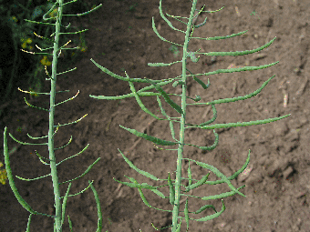
Such locations of range A are listed in table 1. Pods damage is evaluated by using of 9-point scale where 9 means healthy plants and 1 means totally damaged plants. Locations are adjusted by the average level of all varieties on these locations. Differences among them are considerable (e.g. Dolní Újezd 7,9 but Řisuty 5,8) and also yields differ a lot.
Average injury level of all range A locations (7,2) has been used as a key for dividing these trial sites into two groups – with small (Dolní Újezd, Břilice, Červené Janovice, Budkov) respectively high damage (Sychrov a Řisuty).
Fig. 1 shows yields of thus separated locations. We can see a significantly lower yield on heavily damaged sites, where plants were not able to compensate a severe injury. But also differences amongst varieties are visible. Some of them were ready to solve this difficult situation better than the others.
Analogously are constructed table 2 and fig. 2 in the range B, where less damaged trial sites are Koloveč, Bílov, Slatiny, Výčapy and hardly injured Kunín, Chyše and Sloveč.
In the fig. 3 and fig. 4 yields of all varieties and localities are represented as a function of injury level. A positive correlation between damage and drop of the yield is here significant.
Despite of visible differences there is a need to be careful in their interpretation, because of only one-year results from a limited number of trial sites.

