CANOLA INDUSTRY IN SOUTH AUSTRALIA

M. L. Stanley¹ and T. D. Potter²

¹Primary Industries and Resources South Australia, Box 1783, Port Lincoln, SA, 5606, stanley.mark@pi.sa.gov.au

²South Australian Research and Development Institute, Box 618, Naracoorte, SA, 5271, potter.trent@pi.sa.gov.au

ABSTRACT

The canola industry in South Australia is currently worth $82 million to the state economy. Canola is now the predominant oilseed crop in South Australia, with 136,000 hectares grown in 1998. Canola is currently the third largest crop in the state after wheat and barley. It is grown in all agricultural districts in the state, even where annual rainfall is as low as 325mm. There is no breeding program for canola in South Australia, but strong links exist with national breeding programs. Canola crops have provided an opportunity for diversification on farms in South Australia. Close to 40% of the crop in South Australia is sown to triazine tolerant varieties due to brassica weeds problems and to manage herbicide resistance in weeds. Only 20,000 tonnes of oilseeds are crushed in South Australia. The bulk of the canola crop is exported. South Australia is well placed for the export market, with production being close to the coast, good storage facilities and strategically positioned port facilities along the coastline. The outlook for the canola industry in South Australia is promising. The states agricultural areas can potentially grow 0.5 million hectares of canola, producing 0.75 million tonnes of seed. Issues facing canola industry development in South Australia include the introduction of genetically modified (GMO) canola varieties; the introduction of alternative oil type rapeseed varieties; the threat of disease, especially Blackleg, to the continued viability of the industry; and gross margins remaining competitive with other broad acre crops.

KEYWORDS

Hectares, tonnes, production, research, crop

INTRODUCTION

The South Australian canola industry accounted for 11.9% of canola production in Australia in 1998/99. The industry was worth $82 million at the farm gate to the economy of South Australia. Canola is the predominant oilseed crop in South Australia. Safflower, linseed and sunflower are also grown but in significantly less quantities.

Canola has grown from being a relatively minor crop in the late 1980’s to now being the third largest broadacre crop in the state after wheat and barley. Since 1990 the area sown to canola has increased from approximately 5,000 hectares producing 6,000 tonnes to 136,000 hectares producing 200,000 tonnes in 1998 (Figure 1). The increase in area sown has been largely at the expense of pasture, as sheep numbers have declined and cropping intensity increased in recent years. To a lesser extent canola has replaced feed grains such as barley and oats, and grain legumes in areas where they have proven to be unreliable.

Figure 1. Canola production in South Australia 1992 to 1999.
(Hogg, 1992 to 1997)

* estimated

Canola is now grown in all agricultural districts in the state. Crops are being grown in districts with average annual rainfall as low as 325mm. The area sown to canola is also increasing in the high rainfall pastoral districts (greater than 500mm average annual rainfall) of the state’s South East. There are also small areas of irrigated canola in the South East of the state.

The quality of canola in South Australia in the three year period 1995 to 1997 has been consistently better than most other states. Over that period oil content has averaged 41.8%, protein has averaged 34.9% and glucosinolates have averaged 5.5 micromoles (Table 1).

Table 1. Average quality of bulk canola delivered by state, 1995 to 1997.
(Mailer and Colton, 1995, 1996, 1997)

State | Oil % | Protein % | Glucosinolates (micromoles)
South Australia | 41.8 | 34.9 | 5.5
Victoria | 43.1 | 32.2 | 5.5
NSW | 40.4 | 36.4 | 5.5
Western Australia | 40.5 | 33.4 | 8

ROLE OF CANOLA

Farming systems in South Australia are characterised by efficient production processes. Canola has fitted well into these farming systems, providing an opportunity for diversification on farms. Canola crops have been profitable in their own right, have provided a break crop in cereal and grain legume crop rotations, and have complemented machinery and resources being used on farms for other crops.

Canola has been grown in all parts of the cropping rotation, following pasture, cereal and grain legume crops. Canola yields have consistently shown to be superior following a pasture phase (Figure 2), due to the build up in available nitrogen. Cereals crops have most commonly been grown after canola because of the highly effective disease break that canola provides.

Figure 2. Canola performance following different crops in South Australia.
(Stanley, 1995, 1996, 1997)

In recent years malting barley has been grown more often than wheat following canola. This is because of the drain on soil nitrogen by the canola crop, and subsequent reduction in protein levels of following cereal crops. Protein content in wheat following canola has been observed to be up to 3% lower than the protein content of wheat following a grain legume crop or legume pasture.

The development of canola varieties with a shorter growing season requirement offer grain growers in the lower rainfall districts of the state a viable cereal disease break crop alternative to grain legumes, which are unreliable in these environments.

In many low rainfall areas of the state, triazine tolerant (TT) canola is now grown to control brassica weeds. Wild radish and some herbicide resistant weeds in higher rainfall areas are also controlled with TT canola. In 1998 between 35 and 40% of the canola grown in South Australia was sown with TT varieties. While TT varieties result in lower grain yields and oil content, they have greatly expanded the area sown to canola in recent years.

It is envisaged that canola will form a stable, long term part of cropping systems in South Australia, given the profitability of the crop remains competitive with other crop types. In recent years canola has been amongst the most profitable crops grown on farms in South Australia (Figure 3).

Figure 3. Gross margin estimates for APW wheat, malting barley and canola in 400mm annual rainfall zone in South Australia.
(Warren and Wurst, 1995, 1996, 1997, 1998)

MARKETS AND PROCESSING

The domestic and export markets for canola in South Australia are free from regulation. There is competition between crushers, private exporters and statutory marketing bodies. The main buyers competing for canola in South Australia have been AWB Limited, the Australian Barley Board, the NSW Grains Board, Seedex, Cargill and Bustan (Thomas, 1996).

Figure 4. Export grain ports and main canola growing areas in South Australia.

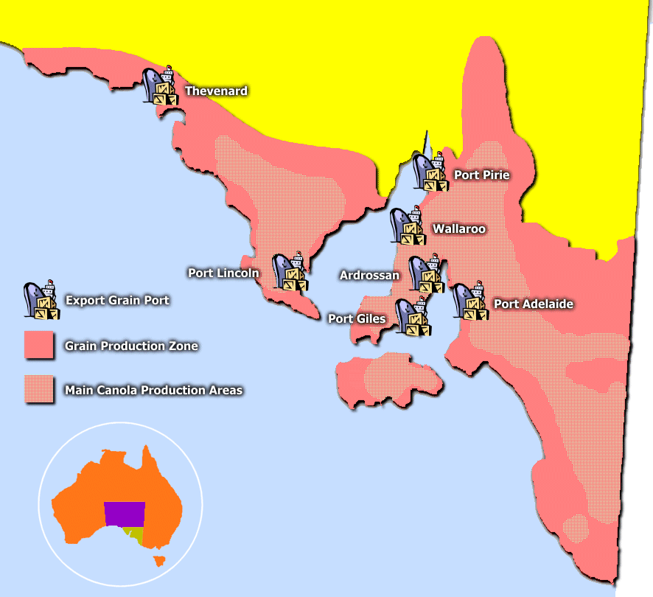

Only 20,000 tonnes of canola is crushed in South Australia. The bulk of the crop is exported, with some seed making its way into the eastern states where it is crushed. The main export markets for South Australian canola are China, Japan, Mexico, Europe and Asia. South Australia is well placed for the export market, with production being close to the coast, good storage facilities and strategically positioned port facilities along the coastline (Heaton) (Figure 4).

RESEARCH AND DEVELOPMENT

While there is no breeding program for canola in South Australia, strong links exist between the South Australian Research and Development Institute (SARDI) and both private and public breeding programs interstate. Early generation evaluation trials conducted by SARDI researchers ensure that those lines with local adaptation are identified and further developed. Canola variety evaluation and agronomic research carried out by SARDI has been critical in providing accurate, independent research data to the rapidly growing industry.

TOPCROP Canola Check has been an important extension vehicle for providing new growers with the confidence to successfully grow canola. Canola Check discussion groups have been mostly facilitated by Primary Industries and Resources South Australia agronomists, bringing together new growers, experienced growers and agribusiness to share information in an informal atmosphere, ensuring that canola growing experiences are successful.

THE FUTURE

Currently only 5% of the cropping area of South Australia is sown to canola (Figure 5). However, the outlook for the canola industry in South Australia is promising with the potential to grow up to 500,000 hectares of canola, producing approximately 750,000 tonnes of seed. This is based on achieving a 16% share of the current total cropping area in the state, and allowing for canola to be grown once in a four-year rotation so that potential losses from Blackleg are minimised. The figure also allows for less canola production in the drier cropping districts of the state. The advent of herbicide resistant varieties of canola, and the development of Brasicca juncea with canola quality, could see the area sown to canola increase even further.

Issues facing the development of the canola industry in South Australia include:

- The introduction of GMO canola varieties. This relates to the ethical, agronomic and marketing issues to do with GMO varieties.
- The introduction of alternative oil type rapeseed varieties, which also has links with the introduction of GMO canola.
- The threat of disease, pests and weeds to the continued viability of the industry. This refers to immediate threats such as Blackleg, herbicide resistant weeds and snail contamination, as well as other diseases and pests that may emerge as a threat to the crop in the future.
- Prices for canola remain competitive with other broad acre crops.
- Costs of production do not rise substantially making gross margins for oilseeds unattractive.
- Variability in area sown to canola and yield due to late seasonal breaks in low rainfall areas and the effect of occasional drought.

Figure 5. Breakdown of area sown to different field crops grown in South Australia in 1998.
(Lewis, 1998)

REFERENCES

Heaton Consultancies (prepared by), “Canola Oil – An Investment Opportunity”, Government of South Australia.

Hogg, Steven (1992 to 1997), “Crop and Pasture Report”, Primary Industries South Australia.

Lewis, David (1998), “Crop and Pasture Report”, Primary Industries and Resources South Australia.
Mailer, R.J. and Colton, R.T. (1995, 1996, 1997), “Quality of Australian Canola, Volumes 3,4 and 5)”, Canola Association of Australia.

Stanley, M.L. (1995, 1996, 1997), “Canola Check State Report”, Primary Industries South Australia

Thomas, Michael (1996), “South Australian Oilseed Industry Profile”, Primary Industries South Australia.

Warren, P and Wurst, M (1995, 1996, 1997, 1998), “Crop and Livestock Gross Margin Estimate”, Primary Industries and Resources South Australia.

